How to use PEAClient for doing CSD201_PE?
Steps to be done:

1. Download the file named PEA_Client.zip (the file name may be changed for semesters). Extract the file and run PEALogin.exe. The login window will appear as below:
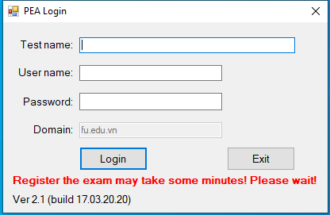 | A student must enter test name given by the proctor, user name, password (used to login to FU local network), then click Login.

2. Upon successful login, the window below will appear:
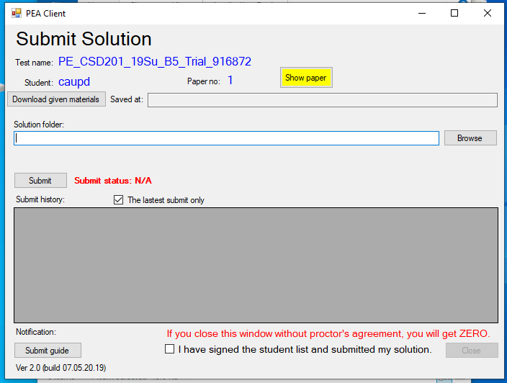 | Create a folder to store given files, e.g. C:\CSD_given (1)  Click the button “Download given materials”, then select the folder (1) and click Ok to save given files. Click the button “Show paper” to view exam questions, edit given projects (Q1, Q2, Q3) to complete them according to the exam’s requirements.  Important notes:  Do not use package in projects Q1, Q2 and Q3.  Do not use accented Vietnamese when writing comments  Only one submission is accepted for marking (you can submit more times, but the newer will overwrite the older).  Do not submit un-coded project.

Submission: Create a folder with arbitrary name, e.g. CSD_PE (2). Create subfolders according to your coded projects, e.g. if you have edited and want to submit 3 projects Q1, Q2 and Q3 then create 3 subfolders Q1R, Q2R and Q3R inside (2), and copy
MyList.java from Q1\src to Q1R  BSTree.java from Q2\src to Q2R  Graph.java from Q3\src to Q3R | 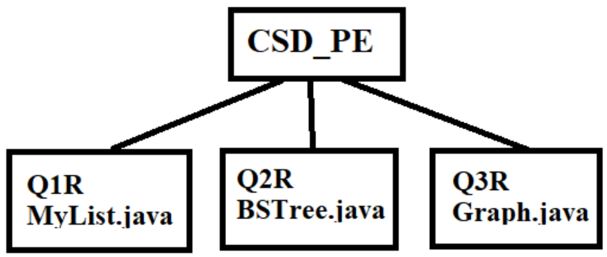
Do not submit un-edited file. E.g. if you did not write code in Graph.java file, then you don’t need to create Q3R. When submiting, you select the folder (2) and click Submit button (do not compress it).

You can click the button “Submit guide” to see guide as below. However this guide is used for other courses, thus it does not contain detail explainations.
